Experiment:-19

Problem Statement:-
In multi-user Linux environments, system administrators and security professionals often need to monitor user login status for example, to detect authorized access, synchronize tasks with user activity, or trigger actions only after a specific user logs in. Automating this monitoring avoids continuous manual checking and ensures timely response.
The problem is to write a shell script that checks whether a specified user is logged in to the system and continues checking at regular intervals (every 30 seconds) until the user logs in, demonstrating looping, conditional checks, and time-based execution in Bash scripting.

Aim:-Shell script to check whether a user is logged in and recheck every 30 seconds until success.

Procedure:-
- Writing the Shell Script
- Open the terminal.
- Create a script file: nano check_login.sh

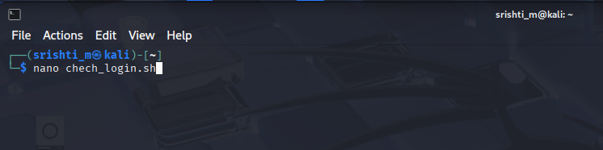

3. Enter the script:
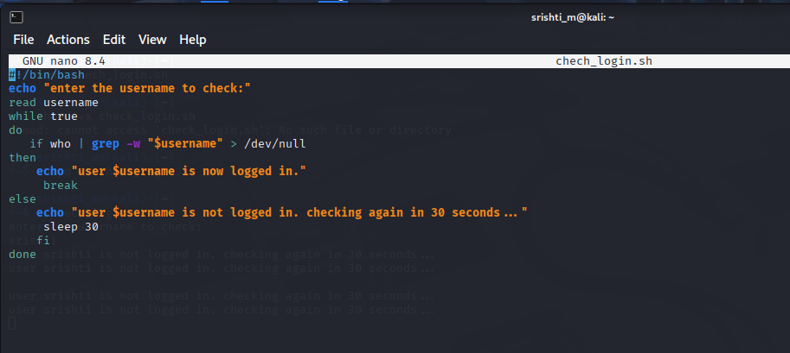

4. Save and exit the editor.
5. Make the script executable: chmod +x check_login.sh

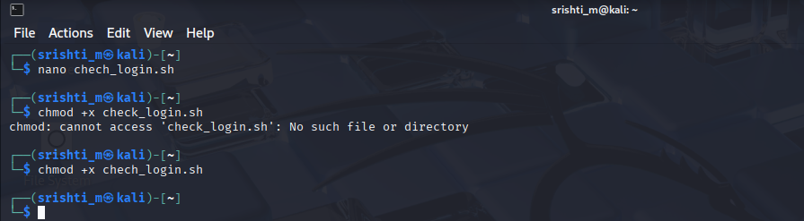

B. Executing the Script
6. Run the script: ./check_login.sh
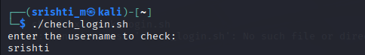

7. Enter a valid username when prompted.
